

Lab Report

Submitted By Ijlal Ahmad
Submitted To Mr. M Zafarullah
Date 21-02-2025
Subject CN

LAB 01
Straight-Through Cable:
A straight-through cable is the most common type of Ethernet cable. It’s like a one-way street where the wires inside the cable run straight from one end to the other in the same order.

Uses:
You use this cable to connect different types of devices, like a computer to a router, a computer to a switch, or a router to a modem. It’s like connecting two people who speak different languages—they need a straightforward connection to communicate.

Example:
Connecting a computer to a router.

Crossover Cable:
A crossover cable is a special type of Ethernet cable where some of the wires inside are "crossed over." This means the transmit and receive wires are swapped between the two ends.

Uses:
You use this cable to connect similar devices, like a computer to another computer, a switch to another switch, or a router to another router. It’s like two people speaking the same language, they need to swap roles (who’s talking and who’s listening) to have a proper conversation.

Example:
Connecting one computer to another computer

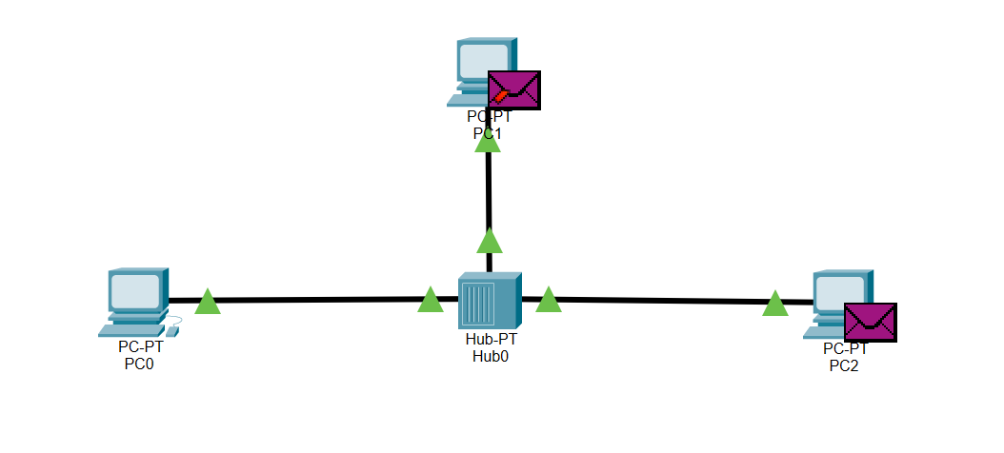
Explanation
IN the above Diagram, we take three Pcs which is named as PC0, PC1 and PC2 and one Hub named Hub0
The IP address of PC0 is 10.0.0.1
The IP address of PC1 is 10.0.0.2
The IP address of PC2 is 10.0.0.3
Then we add a PDU (protocol data unit) to PC0 and PC2 to check the connectivity between the PC0 and PC2 while we didn’t add PDU to PC1 So PC1 is not connected.
When we run the simulation, we sees that the PDU goes from PC0 to PC1 and PC2, PC2 accept it and PC1 didn’t accept it which means that PC0 and PC2 are connected successfully while PC1 is not connected.

LAB 02

